Budget Rent A Car 
of British Columbia

Global Information System

Contract Adjustments Business Design

Version 2.00

Note: The information contained in this document is confidential and may not be disclosed to any parties outside of Budget Rent a Car of British Columbia without written consent by one of its officers.
Copyright (C) 2000 Budget Rent a Car of British Columbia
Table of Contents
1. Functional Area Business Design 1
1.1. Contracts 1
1.1.1. Process Description 1
1.1.2. Screens 1
1.1.2.1. Contract Adjustments Screen 1
1.1.2.1.1. Payment Tab 7
1.1.2.1.2. Adjustments Tab 21
1.1.2.1.3. Comments Tab 33
1.1.2.2. Vehcile Check In/Check Out Adjustment Sub-Screen 36
2. Revision History 41
2.1. Version 2.00 41

Functional Area Business Design

Contracts

Process Description

Screens

Contract Adjustments Screen
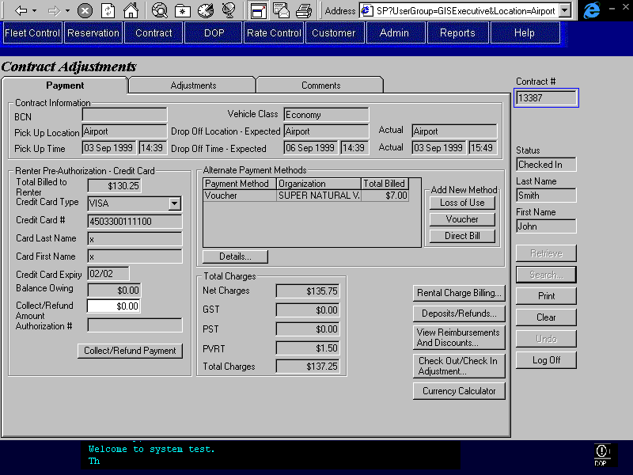
Purpose
The Contract Adjustment screen allows adjustments to be made to a contract after the final check in has been completed. A CSR may use the adjustment screen to make adjustments within the same RBR date as the final check in time. Once the RBR date has changed, only users with adequate security permission such as the Customer Service Agent may make adjustments to the contract.
Available adjustments include:
- Addition of Alternate Billing Methods
- Reassignment of Rental Charge Billing Items and Manual Charge Billing Items to the party authorizing the rental or to an alternate billing party.
- Addition of Adjustment Items. These will include both additional charges, refunds, and reimbursements and may be assigned to the party authorizing the rental or any of the alternate billing parties.
- Addition of discounts. A discount is an adjustment that may be entered as a flat amount or a percentage. If entered as a percentage the discount is calculated based on the vehicle time and km charges only.
- Addition/editing of Comments. Internal comments that do not appear on the printed contract may be added. Printed comments that appear on the printed contract are available to be edited.
- Altering Frequent Flyer plan information. This can only be done if the rate honours frequent flyer plans and a plan has either not yet been added or has been added on the current RBR Date.
- Altering Check In and Check Out times for vehicles on contract for the contract. This is done through a sub-screen that can only be accessed with appropriate authority.
Screen Hierarchy
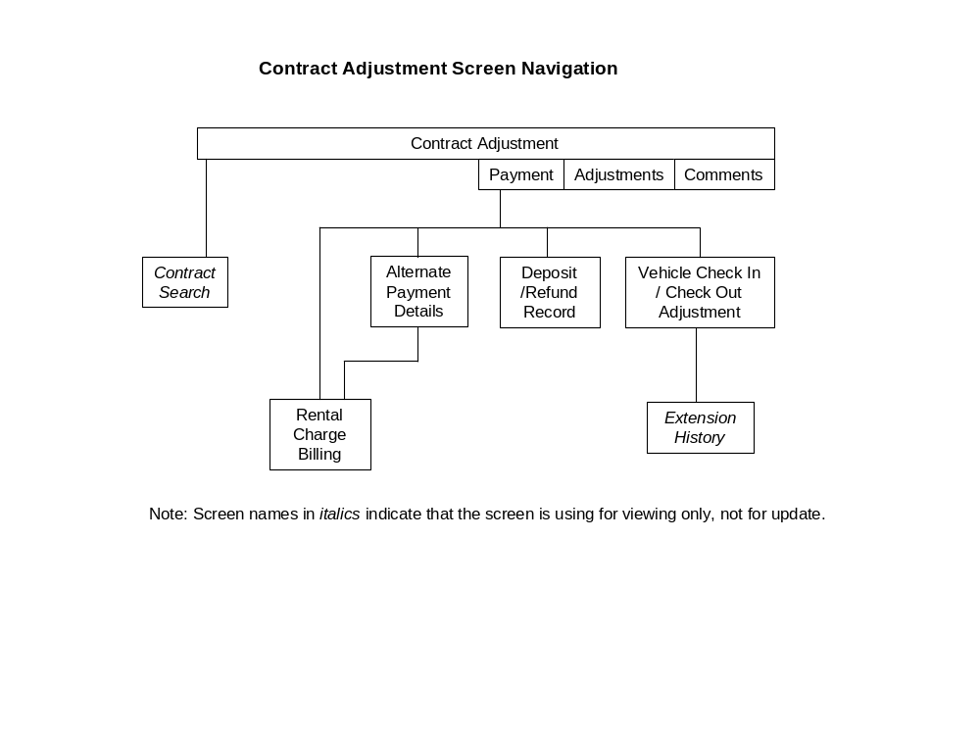Navigation
Search: Opens the Contract Search screen. When the CSR selects a contract from the contract search screen, the Adjustment screen will be populated with the contract information.
Enabled when the Adjustment screen is first opened and when the screen has been cleared using Clear. Disabled when the Adjustment screen is populated with contract information using the Retrieve or Search buttons.
Functions
Retrieve: Retrieves the contract for the contract number or foreign contract number entered and uses it to populate the Adjustment screen. If no contract number is entered and a contract number has been placed in the GIS Selected Contract registry by the Contract Search screen, the number from the registry is retrieved instead.
Enabled when the screen is first opened or when the screen has been cleared using Clear or Undo. Disabled when the screen is populated with contract information using the Retrieve or Search buttons.
When this screen is first opened, a Retrieve is done automatically if a contract number has been placed in the GIS Selected Contract registry by the Contract Search screen.
The contract cannot be retrieved if it has any primary or alternate billing parties that are no longer active on Platinum.
Print: Save and Print the contract. If charges have been reassigned involving direct bill parties, adjusts the amounts charged to each direct bill party for the accounting interface. See the Payment Tab technical notes on Posting Balance Owing to A/R for Direct Bill. If charges have been reassigned involving the renter, adds payments or refunds as required (shown in the Deposits/Refunds Record screen).
The Adjustment Balance Owing must be zero unless the contract has a foreign pick up location and a Contract Interbranch Balance. In that case the balance owing can be less than zero as long as adding the balance owing to the Contract Interbranch Balance will not make the Contract Interbranch Balance less than zero.
Adds the Adjustment Balance Owing to the Contract Interbranch Balance.
Write changes to Contract Charge Items to the Contract Charge Item Audit table. See Technical Notes for more details.
Clear: Disabled once a credit card payment has been processed and save has not been completed.
Undo: Disabled once a credit card payment has been processed and save has not been completed.
Controls
Req*: Y – always mandatory
N – always optional
S – sometime optional (see Comments for details)
D – display only
Field | Source | Req* | Validation | Comments
Contract # | Contract, Contract Number | D |  | Unlocked when the screen is first opened or when the screen has been cleared using Clear or Cancel. Locked when the screen has been populated with contract information using the Retrieve or Search buttons.
Foreign Contract # | Contract, Foreign Contract Number | D |  | Unlocked when the screen is first opened or when the screen has been cleared using Clear or Cancel. Locked when the screen has been populated with contract information using the Retrieve or Search buttons.
Status | Contract, Status | D
Last Name | Contract, Last Name | D
First Name | Contract, First Name | D
Technical Notes
Contract Charge Item Audit Table
In Contract Adjustments whenever Contract Charge Item records are updated for the contract, compare the previous calculated and manual Contract Charge Item records to the updated records. For each previous calculated or manual Contract Charge Item record, check whether there is a matching updated record. There is a match if the following attributes are the same in both records.
- Rental Charge Split ID (calculated charges only)
- Charge Type (manual charge only)
- Amount
- GST Amount
- PST Amount
- PVRT Amount
- GST Amount Included (calculated charges only)
- PST Amount Included (calculated charges only)
- PVRT Amount Included (calculated charges only)
- Contract Billing Party ID
When there is no matching updated record, write an Audit Contract Charge Item record which is a copy of the old record. Then write a second Audit Contract Charge Item record which is a reversal of the record just written with the Business Transaction Id now set to the Id of the current transaction. The reversal will have all amounts in the record reversed (i.e. reverse sign).

Payment Tab
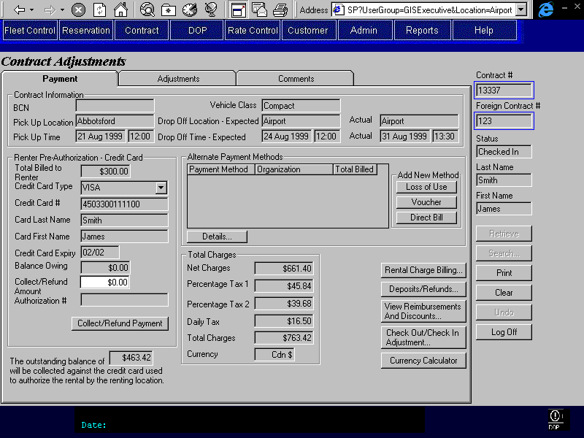

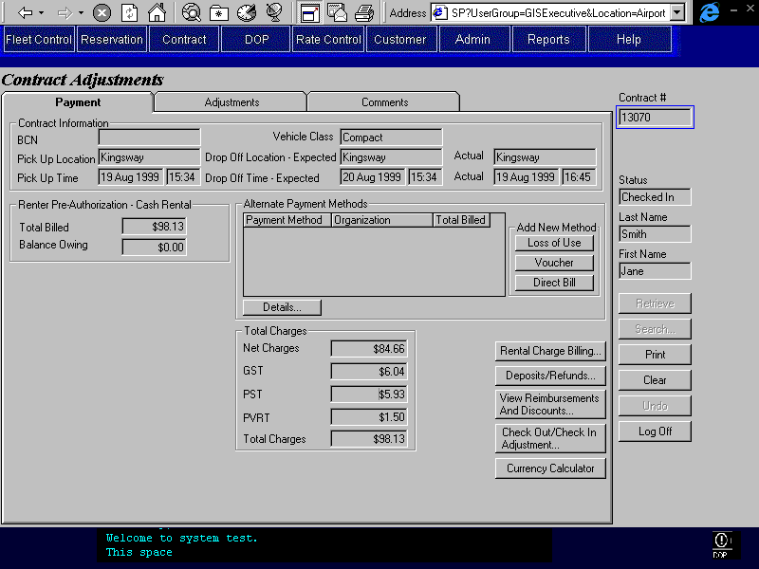
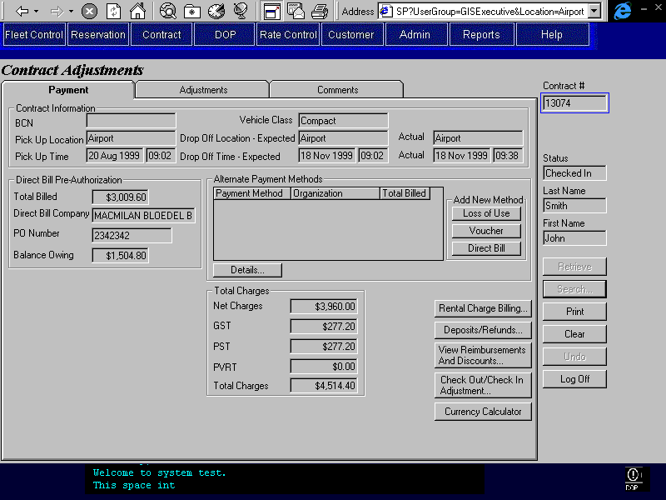
Purpose
The Payment tab displays information about the contract, the authorizing party, and the alternate payment methods.
The upper portion of the tab displays the basic contract information. This information relates to the information that was displayed at the top of the Contract Open/Check Out, Changes During Rental, and Check In screens.
Below the contract information, information about who authorized the rental is displayed – renter credit card, renter cash, or direct bill. The total amount billed to this party is also displayed along with the adjustment balance owing. In the case of a renter credit card rental authorization, the amount to collect or refund may be entered so that the adjustment balance owing can be overridden. This allows the CSR to collect an amount less or greater than the adjustment balance owing. For example, an amount less may be collected in the event the total balance owing amount is declined. Any amount collected or refunded from/to the credit card will then be removed from the adjustment balance owing and the payment or refund will be displayed on the Deposits and Refunds screen.
For renter cash authorizations and direct bill, the balance owing is displayed and cannot be overridden.
The adjustment session cannot be saved with a positive adjustment balance or a negative adjustment balance with an absolute value greater than the interbranch balance. Note that for direct bill authorized contracts the adjustment balance is automatically posted to A/R upon save and is thereby zero at save. For credit card or cash authorized rentals, if the payment cannot be collected or refunded on the authorizing credit card, or by a cash method, the CSR must add an alternate payment method for the appropriate A/R account and bill the remaining adjustment amount to that account. Once a credit card payment or refund has been issued the CSR cannot exit the screen without printing and therefore saving the contract.
Upon saving (printing the contract) the balance owing for direct bill parties will be:
- If balance owing is positive:
Posted to A/R - for direct bill authorizations.
(Cash pre-authorizations and renter credit card pre-authorizations where the entire balance was not collected from the credit card must be manually charged (using an alternate payment method) to the appropriate A/R account by the CSR.)
- If balance owing is negative:
Posted to A/R – for direct bill authorizations
(Cash pre-authorization and renter credit card pre-authorization where the negative balance absolute value is greater than the interbranch balance. If the amount greater than the interbranch balance was not refunded to the credit card, then the CSR must manually enter a Mail Refund in the Deposit/Refund screen or re-assigned charges to or away from the appropriate A/R account before saving.)
Next to the information about who is authorizing the rental is the alternate billing information. This information includes the alternate billing methods, the alternate billing organization name, and the amount billed to each alternate method. New alternate payment methods may be entered in this section. Assignment of new charges is completed on the next tab. Re-assignment of existing charges is completed on the Rental Charge Billing screen. Upon saving (printing the contract) any net difference owed to or by an alternate payment party will be posted to A/R.
The contract net charges, GST, PST, PVRT, and total charges are displayed below the alternate billing methods.
For Rentback or Foreign contracts where the Renting Location is not BRAC, the following applies:
- For credit card authorizations, the credit card fields will be updateable if they have not already been entered. All the fields must be entered and valid before a payment can be processed. Once a payment has been processed against the card or on Save, the populated fields will be locked.
- An Interbranch message, advising the CSR that the outstanding balance will be collected by the renting location, may have been displayed on the Check In screen and there may then be an outstanding balance on the contract (this is referred to as the contract interbranch balance). In this case, the Interbranch message will display below the payment information along with the current contract interbranch balance (not including the adjustment outstanding balance). Upon saving the contract adjustment, the contract interbranch balance will be adjusted to reflect the net outcome of the adjustments. Since a positive balance for the current adjustments will not be allowed, the adjustment can only lower the contract outstanding balance. In addition, the adjustment cannot reduce the contract outstanding balance to less than zero.
- The GST, PST, and PVRT tax fields will be labelled Percentage Tax 1, Percentage Tax 2, and Daily Tax.
- Display the Contract Currency in the Total Charges section.
Navigation
Rental Charge Opens the Rental Charge Billing screen where existing charges may be
Billing: viewed and resplit and/or reassigned between the authorizing party and the alternate payment parties. Charges may not be added or removed in this screen.
Deposit Opens the Deposit/Refund screen where the details of cash
/Refund Record: deposits and refunds, credit card deposits and refunds, and additional credit card authorizations can be viewed. New cash and credit card deposits and refunds may be added here.New credit card authorizations cannot be entered, but payment can be collected against authorizations already taken.
View Opens the Reimbursment/Discount sub-screen for viewing only. The Add
Reimbursement Discount and Add Reimbursment sections will not be visible.
/Discount:

Check Out Opens the Check Out/Check In Adjustment Subscreen. Checks to ensure that
/Check In the user has adequate authority before opening the screen.
Adjustments:
Currency Calculator: Opens the Currency Calculator sub-screen where amounts may be converted from one currency to another. No payments or refunds occur in this sub-screen.

Add Loss of Use: Opens the Loss of Use Alternate Payment Method Details screen, where the CSR may search and select the appropriate alternate billing organization and enter the required details.
Disabled and invisible if Contract Pick Up Location is not a BRAC location.
Add Voucher: Opens the Voucher Alternate Payment Method Details screen, where the CSR may search and select the appropriate alternate billing organization and enter the required details. Upon exiting this sub-screen, the Rental Charge Billing screen will be opened.
Add Direct Bill: Opens the Direct Bill Alternate Payment Method Details screen, where the CSR may search and select the appropriate alternate billing organization and enter the required details.
Details: Opens the appropriate Alternate Payment Method Details screen (Loss of
(Alternate Use, Voucher or Direct Bill) so that the CSR can view and update
Payment Method) information. Search criteria and search result are not visible in the details screen.

Functions
Collect/Refund Collects payment or issues refund for the amount specified on the screen for
Payment: the authorizing credit card. For details on the credit card payment process,
(Credit Card) see the Credit Card Interface document. Not visible when Contract Currency is US$.
If the automated payment facility is not available or the credit card type has no automatic payment, opens the Manual Credit Card Transaction sub-screen and populates it with the credit card and payment or refund amount information from this tab. After the sub-screen is closed, the authorization number returned will be displayed on this tab.
Generate Accounting Interface entries for the payment. For details, see the section on Accounting Interface Entries for Contract Adjustments in the Contracts Part I document.

Controls
Req*: Y – always mandatory
N – always optional
S – sometime optional (see Comments for details)
D – display only
Field | Source | Req* | Validation | Comments
Contract Information
BCN | Contract, Customer Program Number | D
Pick Up Location | Contract, Pick Up Location ID | D |  | Location name displayed.
Pick Up Time | Contract, Pick Up On | D
Vehicle Class | Contract, Vehicle Class Code | D |  | Vehicle Class Name is displayed.
Drop Off Location – Expected | Contract, Drop Off Location ID | D |  | Location name is displayed.
Drop Off Time - Expected | Contract, Drop Off On | D
Drop Off Location – Actual | Vehicle On Contract, Actual Drop Off Location ID | D |  | For the last Vehicle On Contract record for the selected contract. Location name is displayed.
Drop Off Time - Actual | Vehicle On Contract, Actual Check In | D |  | For the last Vehicle On Contract record for the selected contract.
Total Charges
Net Charges |  | D |  | Calculated by GIS.  See Technical Notes below.
GST or Percentage Tax 1 |  | D |  | Calculated by GIS.  See Technical Notes below.  Label is Percentage Tax 1 if the Foreign Contract # is populated, otherwise GST.
PST or Percentage Tax 2 |  | D |  | Calculated by GIS.  See Technical Notes below.  Label is Percentage Tax 2 if the Foreign Contract # is populated, otherwise PST.
PVRT or Daily Tax |  | D |  | Calculated by GIS.  See Technical Notes below..  Label is Daily Tax if the Foreign Contract # is populated, otherwise PVRT.
Total Charges |  | D |  | Calculated by GIS.  Sum of Net Charges, GST, PST, and PVRT (Four field directly above).
Currency | Contract, Currency ID | D |  | Display only when the renting location is a foreign location.
Renter Credit Card Pre-Authorization |  |  |  | Display when Renter has pre-authorized the rental with a credit card: Contract Billing Party with Billing Type ‘Primary’ has Billing Method ‘Renter’ and Renter Primary Billing has Renter Authorization Method ‘Credit Card’. Hide otherwise.  Credit card information is from the credit card used to authorize the rental. Renter Primary Billing, Credit Card Key.
Total Billed to Renter |  | D |  | Calculated by GIS.  Total of all payments and refunds for the authorizing party. This will equal the sum of all payments and refunds on the Deposit/Refund sub-screen.
Credit Card Type | Renter Primary Billing, Credit Card Key;  Credit Card, Credit Card Type ID | D
Credit Card # | Renter Primary Billing, Credit Card Key;  Credit Card, Credit Card Number | D
Card Last Name | Renter Primary Billing, Credit Card Key;  Credit Card, Last Name | D
Card First Name | Renter Primary Billing, Credit Card Key;  Credit Card, First Name | D
Credit Card Expiry | Renter Primary Billing, Credit Card Key;  Credit Card, Expiry | D
Balance Owing |  | D |  | Calculated by GIS.  See technical notes.
Collect/Refund Amount | Contract Payment Item, Amount | N |  | Defaults to Balance Owing.
Authorization # | Credit Card Payment, Authorization Number | D |  | Populated only when payment completed.
Cash Rental |  |  |  | Display when Renter has pre-authorized the rental with a cash rental deposit: Contract Billing Party with Billing Type ‘Primary’ has Billing Method = Renter and Renter Primary Billing has Renter Authorization Method ‘Cash’. Hide otherwise.
Total Billed |  | D |  | Calculated by GIS.  Total of all payments and refunds for the authorizing party. This will equal the sum of all payments and refunds on the Deposit/Refund sub-screen.
Balance Owing |  | D |  | Calculated by GIS.  See technical notes.
Direct Bill Pre-Authorization |  |  |  | Display when the rental has been pre-authorized by a direct bill company: Contract Billing Party with Billing Type ‘Primary’ has Billing Method ‘Direct Bill’. Hide otherwise.
Total Billed | Contract Payment Item, Amount and Payment Type | D |  | Calculated by GIS.  Total of all payments and refunds for the authorizing party. Sum of all Contract Payment Item, Amount where Contract Payment Item, Payment Type is A/R.  Following Save this will equal Contract Billing Party, Amount Removed from Available Credit.
Direct Bill Company | Contract Billing Party, Customer Code | D |  | Where Contract Billing Party, Billing Type is Primary.  AR Customer Master, Address Name is displayed
PO Number | Direct Bill Primary Billing, PO Number | D |  | Default from Direct Bill Authorization.
Adjustment Balance Owing |  | D |  | Calculated by GIS.  See technical notes.
Alternate Payment Methods
Payment Method | Contract Billing Party, Billing Method | D
Organization | Contract Billing Party, Customer Code | D |  | AR Customer Master, Address Name is displayed
Total Billed | Contract Billing Party, Amount Removed from Available Credit | D |  | Calculated by GIS from the rental charges assigned to the alternate payment organization on the Rental Charge Billing Screen and the Adjustments Tab.
Interbranch Message | Contract, Interbranch Balance | D |  | Display only if Interbranch Balance is populated.
Contract Interbranch Balance | Contract, Interbranch Balance | D |  | Display only if Interbranch Balance is populated.
Technical Notes
Exchange Rate:
When calculating the exchange rate for cash deposits in foreign currency, use the exchange rate for the location if there is one; otherwise use the standard exchange rate.
Calculating Net Charges, GST, PST, and PVRT for the Contract:
To calculate the net charges for the contract, the following should be summed:
- All charges (positive and negative) on the Rental Charge Billing screen.
- All reimbursements on the Reimbursement and Discount screen. Ignore the discounts on this screen as these are already shown in the Rental Charge Billing screen as charge items.
- All adjustments on the Adjusments tab (previous and current)

To calculate the GST, PST, and PVRT, the total for each tax should be summed using the same sources as listed above for the net charges.

Balance Owing Calculations for Party Authorizing Rental:
When new adjustment or discounts have been added:
- Include total of all new adjustments and discounts including any applicable taxes
When Rental Charge Billing Items and manual charge billing items have been reassigned:
- Include the Sum of all Rental and Manual Charge Billing Items assigned to the authorizing party, plus any Previous Adjustments, minus the net of any payments and refunds collected from the authorizing party, minus the contract interbranch balance.

Posting Balance Owing or To Be Paid to A/R for Direct Bill (rental authorization or alternate payment party):
For every alternate payment organization (each Contract Billing Party with Billing Type ‘Alternate’), record an A/R contract payment as follows (an A/R contract payment is recorded by creating a Contract Payment Item and an A/R Payment):
- Contract Payment Item
- Set Payment Type to ‘A/R’
- Set Amount to the calculated balance owing amount for the alternate payment organization for this Adjustment session (the net change of charges to this party).
- Set Collected On to the current date and time
- Set Collected By to the current user ID
- Set Collected At Location ID to the current location ID
- Set RBR Date to the current RBR date
- A/R Payment
- Set Contract Billing Party ID from Contract Billing Party
- Set Interim Bill Date to null
If a direct bill organization authorized the contract (Contract Billing Party with Billing Type ‘Primary’ has Billing Method ‘Direct Bill’), record an A/R contract payment as follows (an A/R contract payment is recorded by creating a Contract Payment Item and an A/R Payment):
- Contract Payment Item
- Set Payment Type to ‘A/R’
- Set Amount to the calculated balance owing amount for the direct bill organization for this Adjustment session (the net change of charges to this party).
- Set Collected On to the current date and time
- Set Collected By to the current user ID
- Set Collected At Location ID to the current location ID
- Set RBR Date to the current RBR date

- A/R Payment
- Set Contract Billing Party ID from Contract Billing Party
- Set Interim Bill Date to null

Adjustments Tab
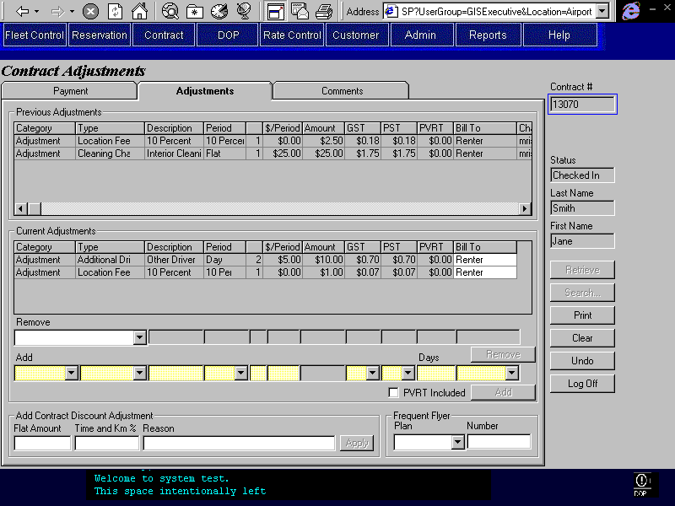
Purpose
This tab displays all adjustments applied to the contract and to which party the adjustments have been billed. The charges are split into three categories:

- Previous Adjustments – those charge items that have been entered as adjustments using this screen in a previous session. This includes any previous Contract Discount Adjustments entered in the Adjustments screen.
- Current Adjustments – those charge items that are being added in the current session. This will include different charge categories such as reimbursements and regular adjustments. Different accounting entries will be generated based on the charge category selected.
- Contract Discount Adjustment – discount, percent or flat, that is being added in the current session. Upon selecting ‘Apply’ the discount entered will be added to the Current Adjustment grid.
To add new charges or discounts the CSR will enter the new information in the Add Adjustments (in the Current Adjustment section) or the Contract Discount Adjustment sections. New charges may be billed to the party authorizing the rental or one of the alternate billing parties. Discounts are automatically assigned to the authorizing party but may be reassigned once they are displayed in the Current Adjustments section. Once the new charges or discounts have been added and the changes saved (by printing the contract), the added charges and discounts will appear in the Previous Adjustments section. To delete an adjustment in the Current Adjustment section the CSR will select the Adjustment from the Charge Category/Type drop down in the Remove Adjustment section. Note that Previous Adjustments cannot be removed. For each session a location fee adjustment will be automatically calculated for the current adjustments added during that session. See Contract Part 1 for more details on the calculation of location fees.
This tab is only used to enter adjustments where the amount will be billed by BRAC. Note that BRAC may bill the amount to a foreign location. To record contract adjustments done at foreign locations, the comments fields in the comments tab will be used.
To add a new Voucher Alternate Payment method that is inclusive of tax, the CSR would follow the following procedure:
Add the Voucher in the Alternate Payment Method section on the Payment tab. In the Rental Charge Billing Screen, the CSR will split the charge line so that the Voucher is not charged the included tax. The included tax will be charged to the Renter. The CSR will then exit the Rental Charge Billing screen and add a new adjustment that refunds the included tax amount to the Renter. The correct amounts have now been charged to the Voucher and Renter. Accounting will have to manually deal with the tax implications and correct the amount of tax being paid.
Frequent flyer information is also displayed and may be updated if it is blank or was added to the contract on the current RBR Date. If the rate used for the contract does not honour frequent flyer plans, then the frequent flyer fields will be invisible.
Navigation
N/A
Functions
Add Discount: Adds discount entered in the Discount Adjustment section to the Current Adjustment section. The appropriate dollar amount and taxes will be calculated by GIS (see Contracts Part 1). Percent discounts will be based on all Time and Km charges for the Contract (including adjustments). The discount is not saved until the Current Adjustments are saved.
Controls
Req*: Y – always mandatory
N – always optional
S – sometime optional (see Comments for details)
D – display only
Field | Source | Req* | Validation | Comments
Previous Adjustments |  |  |  | Display only where Contract Charge Item.Charge Item Type is Adjustment or Reimbursement Adjustment.
Charge Category | Contract Charge Item, Charge Item Type | D
Charge Type | Contract Charge Item, Charge Type | D
Description | Contract Charge Item, Charge Description | D
Period | Contract Charge Item, Unit Type | D
Period (number of periods) | Contract Charge Item, Quantity | D
$/Period | Contract Charge Item, Unit Amount | D
Amount | Contract Charge Item, Amount | D
GST | Contract Charge Item, GST Amount | D
PST | Contract Charge Item, PST Amount | D
PVRT | Contract Charge Item, PVRT Amount | D
Bill To | Contract Charge Item, Contract Billing Party ID | D |  | If Contract Billing Party has Billing Type = Primary and Billing Method = Renter, Renter is displayed. If Contract Billing Party has Billing Type = Primary and Billing Method = Direct Bill, Direct Bill is displayed. Otherwise Contract Billing Party, Billing - AR Customer Master, Address Name is displayed.
Charged By/On | Contract Charge Item, Charged By/Charged On | D
Current Adjustments |  |  |  | Adjustments and Discounts that have been added during the current session and have not yet been saved.
Charge Category | Contract Charge Item, Charge Item Type | D
Charge Type | Contract Charge Item, Charge Type | D
Description | Contract Charge Item, Charge Description | D
Period | Contract Charge Item, Unit Type | D
Period (number of periods) | Contract Charge Item, Quantity | D
$/Period | Contract Charge Item, Unit Amount | D
Amount | Contract Charge Item, Amount | D
GST | Contract Charge Item, GST Amount | D
PST | Contract Charge Item, PST Amount | D
PVRT | Contract Charge Item, PVRT Amount | D
Bill To | Contract Charge Item, Contract Billing Party ID | Y |  | Defaults to the Contract Billing Party with Billing Type = ‘Primary’.  If Contract Billing Party has Billing Type = Primary and Billing Method = Renter, Renter is displayed. If Contract Billing Party has Billing Type = Primary and Billing Method = Direct Bill, Direct Bill is displayed. Otherwise Contract Billing Party, Billing Method - AR Customer Master, Address Name is displayed.
Remove Adjustment
Charge Category/Type |  | N | Value controlled by entries in the Current Adjustments grid. | Concatenation of charge item type and charge type.
Description | Contract Charge Item, Charge Description | D
Period | Contract Charge Item, Unit Type | D
Period (number of periods) | Contract Charge Item, Quantity | D
$/Period | Contract Charge Item, Unit Amount | D
Amount | Contract Charge Item, Amount | D
GST | Contract Charge Item, GST Amount | D
PST | Contract Charge Item, PST Amount | D
PVRT | Contract Charge Item, PVRT Amount | D
Bill To | Contract Charge Item, Contract Billing Party ID | D |  | If Contract Billing Party has Billing Type = Primary and Billing Method = Renter, Renter is displayed. If Contract Billing Party has Billing Type = Primary and Billing Method = Direct Bill, Direct Bill is displayed. Otherwise Contract Billing Party, Billing Method - AR Customer Master, Address Name is displayed.
Add Adjustment
Charge Category | Contract Charge Item, Charge Item Type | Y | Value Controlled by -Category value in Look up table. | Allow only Charge Categories of Adjustment and Reimbursement Adjustment.
Charge Type | Contract Charge Item, Charge Type | Y | Value controlled by Charge Type table.
Description | Contract Charge Item, Charge Description | Y | Free form text
Period | Contract Charge Item, Unit Type | Y | Value controlled by Time Period table. | Must be Flat for Charge Category = Reimbursement Adjustment
Period (number of periods) | Contract Charge Item, Quantity | S | Numeric (positive, zero allowed) | If Period is Flat, then value is 1 and is locked.
$/Period | Contract Charge Item, Unit Amount | Y | Currency  Must be negative if Charge Category is Reimbursement.
Amount | Contract Charge Item, Amount | D | Currency | (number of periods)*($/Period)
GST | Contract Charge Item, GST Amount and GST Exempt and GST Included | Y | Value Yes, No, or Included. | If value Yes then save as Tax Rate,GST * Amount.  If value is No then Contract Charge Item, GST Exempt is true and GST Amount = 0.  If value is Included then Contract Charge Item, GST Included is true and GST Amount = 0. GST Included Amount will be calculated and saved based on the current GST Rate (in Tax Rate table).
PST | Contract Charge Item, PST Amount and PST Exempt and PST Included | Y | Value Yes, No, or Included. | If value Yes then save as PST * Amount (PST rate from in Vehicle Model Year table if populated, otherwise in Tax Rate table).  If value is No then Contract Charge Item, PST Exempt is true and PST Amount = 0.  If value is Included then Contract Charge Item, PST Included is true and PST Amount = 0. Included PST Amount will be calculated based on the current PST price (in Vehicle Model Year table if populated, otherwise in Tax Rate table).
PVRT Days | Contract Charge Item, PVRT Amount and PVRT Exempt | Y | Numeric | If Numeric value entered, save as Tax Rate,PVRT * PVRT Days  If value is 0 then Contract Charge Item, PVRT Exempt is true.
PVRT Included | Contract Charge Item, PVRT Included | N | Check box | If on then PVRT is included. Included days are determined by the number entered in PVRT Days field.
Bill To | Contract Charge Item, Contract Billing Party ID | Y |  | Defaults to the Contract Billing Party with Billing Type = ‘Primary’.  If Contract Billing Party has Billing Type = Primary and Billing Method = Renter, Renter is displayed. If Contract Billing Party has Billing Type = Primary and Billing Method = Direct Bill, Direct Bill is displayed. Otherwise Contract Billing Party, Billing Method - AR Customer Master, Address Name is displayed.
Contract Discount Adjustment |  |  |  | Contract Charge Item, Charge Item Type = Adjustment.  Contract Charge Item, Charge Type = Discount.  See Technical Notes below.
Flat Amount | Contract Charge Item, Amount | S | Must be <= Net Charges displayed on Payment tab and > 0. | One of Amount and % and only one must be entered if Reason is entered.
Time and Km % | Contract Charge Item, Amount | S | Must be <= 100 and > 0 | One of Amount and % and only one must be entered if Reason is entered.  Contract Charge Item, Amount = Time and Km charges * Time and Km%/100
Reason | Contract Charge Item, Charge Description | S | Free form text. | Required when Flat Amount or Time and Km % is entered.
Frequent Flyer |  |  |  | Not visible unless Frequent Flyer Plans Honoured is Yes for the rate selected.  Only updateable if Contract.FF Assigned On Date is null or equal to the current RBR Date.  See Technical Notes for more details.
Plan | Frequent Flyer Plan Member, Frequent Flyer Plan ID | N | Value controlled by Frequent Flyer Plan table | Frequent Flyer Plan name is displayed.
Member | Frequent Flyer Plan Member, Member Number | S |  | Required if Plan is entered. If there is already a Frequent Flyer Member for the Frequent Flyer Plan and the Customer with a Type of Preferred, defaults to that Member Number, defaults to blank otherwise.
Technical Notes
The Look Up table will use a combination of Charge Type and Charge Item Types (Charge Category) where Charge Item Type is used to sort or filter Charge Types. Charge Item Types are Manual, Calculated, Adjustment, and Reimbursement Adjustment. For the Adjustment screen only charge item types of Adjustment and Reimbursement Adjustment apply.
Discount Adjustments:
The discount amount (Contract Charge Item.Amount) is calculated as follows:
- If the discount is flat then Amount = the flat amount entered by the user. Check to make sure that the flat amount is not greater than total amount charged for the contract (before adding taxes).
- If the discount is a percentage then Amount = (total charges due to vehicle time and kms for contract) * (discount percentage)
- The Unit Type is always Flat and the Quantity is always -1 (this will ensure that the discount is negative).
- All discounts must be negative.
When saving the discount the taxes associated with the discount must be calculated as follows:
- Tax Included and Tax Exempt flags will be No execpt where specified below.
- If the contract is exempt from tax (GST or PST) then the tax amount calculated for that tax will be 0. The exempt flag for that tax will then be set to yes for the adjustment (contract charge item).
- For taxes that are not exempt:
      - If the discount is Flat then calculate the tax amount as (flat Amount) * (Tax Rate). Check to ensure that the tax discounted is not greater than the tax charged for the entire contract (for the specified tax type).
      - If the discount is a Percentage, then check to see if the tax is included in the rate:
          - If the tax is included in the rate, then the tax amount is 0 and the Tax Included flag is yes.
          - If the tax is not included in the rate, then calcualate the tax amount as (discount Amount) *(Tax Rate).

Frequent Flyer Plan
Frequent Flyer Plan and Member Number may only be updated if Contract.FF Applied On Date is null or equal to the current RBR Date. When saving the Frequent Flyer Plan and Member Number the Contract.FF Applied On Date will be populated with the current RBR Date.

Comments Tab
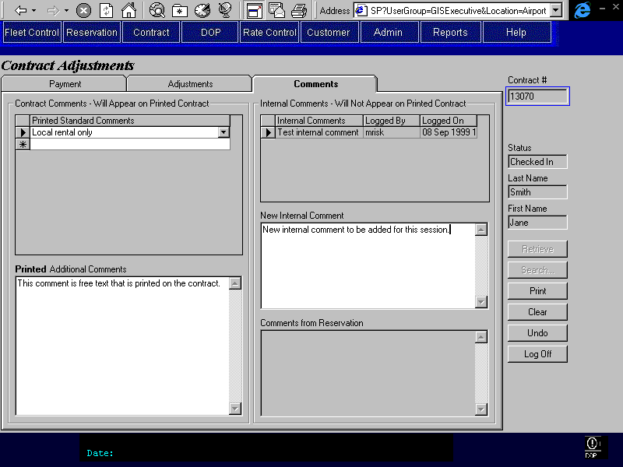
Purpose
The Comments tab is used to view reservation and previously entered internal comments, to enter new internal comments, and to edit the printed comments. This will facilitate communication between different CSRs who may work on the same contract
The Contract Comments section contains the comments that will be printed on the contract. The CSR may select comments from a pre-existing list or enter free text to appear on the printed contract.
The Internal Comments section contains the comments that are for internal use only and will not appear on the printed contract. The CSR may add new comments to this section but cannot alter existing comments. Upon saving changes to the contract, the new comments will be protected and the user id that entered the comment and the time at saving will be recorded. The reservation comments are considered internal comments will therefore not appear on the printed contract.
Navigation
N/A
Functions
N/A
Controls
Req*: Y – always mandatory
N – always optional
S – sometime optional (see Comments for details)
D – display only
Field | Source | Req* | Validation | Comments
Contract Comments
Printed Standard Comments | Contract Print Comment, Standard Print Comment | N | Values controlled by Contract Print Standard Comment table.
Printed Additional Comments | Contract, Print Comment | N | Free form text. Maximum length 255 characters.
Internal Comments
Internal Comment | Contract Internal Comment, Comments | D
Logged By | Contract Internal Comment, Logged By | D
Logged On | Contract Internal Comment, Logged On | D
New Internal Comment | Contract Internal Comment, Comments | N | Free form text. Maximum length 255 characters.
Comments from Reservation | Reservation Comments, Standard Reservation Comment ID; Reservation, Special comments | D |  | Concatenation of Reservation Comments for the reservation and Reservation, Special Comments
Technical Notes
When a new internal comment is saved to the Contract Internal Comment table, the user ID of the person who entered the comment and the date and time that the comment was entered must also be saved.
This comments tab is the same as the comments tab in the Changes During Rental and the Check In screens.

Vehcile Check In/Check Out Adjustment Sub-Screen
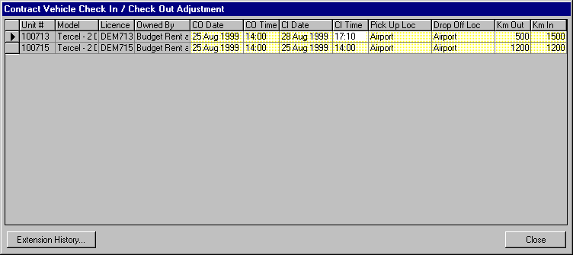
Purpose
The Contract Vehicle Check In/Check Out Adjustment sub-screen displays Check Out and Check In information for each vehicle that was rented on the contract. This sub-screen may only be accessed with appropriate authority.
Each row displays the Check Out and Check In information for a vehicle that was checked out on the contract. This information may be updated, however the updates must not conflict with other vehicles on contract or movements for the same contract or vehicle. See the save function for more details.
For information purposes the extension history for the contract is available for viewing by pressing the Extension History button.
Navigation
Extension History: Opens the Extension History screen and displays all drop off time and location changes for the current contract. Disabled if no drop off history exists.
Functions
Save: Saves the Check In and Check Out information to the Vehicle On Contract table. The following edits are performed:
- There can be no overlaps between movements for a given vehicle
- There can be no overlaps between vehicles on contract for a given vehicle
- There can be no overlaps between movements and vehicles on contract for a given vehicle
- There can be no overlaps between vehicles on contract for a given contract
- Km In must be greater than Km Out
See technical notes for more details and for a description of what Vehicle fields and Contract fields require update upon saving.
Controls
Req*: Y – always mandatory
N – always optional
S – sometime optional (see Comments for details)
D – display only
Field | Source | Req* | Validation | Comments
Vehicle |  |  |  | Displays vehicle information for the current contract.
Unit # | Vehicle On Contract, Unit Number | D
Model | Vehicle, Vehicle Model ID | D |  | Model Name is displayed
Licence | Vehicle Licence History, Licence Plate Number | D |  | The vehicle licence plate that is in effect at the time of vehicle check out is displayed.
Owned By | Vehicle, Vehicle Owning Company | D
Check Out Time  (split into two columns and labeled CO Date and CO Time) | Vehicle On Contract, Check Out | Y | Date and time.  Cannot conflict with the any Vehicle On Contract record or Movement record for this vehicle and contract.  See Save function.
Check In Time  (split into two columns and labeled CI Date and CI Time) | Vehicle On Contract, Actual Check In | Y | Date and time.  Cannot conflict with the any Vehicle On Contract record or Movement record for this vehicle and contract.  See Save function.
Pick Up Loc | Vehicle On Contract, Pick Up Location ID | Y | Value controlled by location table.
Drop Off Loc | Vehicle On Contract, Actual Drop Off Location ID | Y | Value controlled by location table. | .
Km Out | Vehicle On Contract, Km Out | Y | Numeric
Km In | Vehicle On Contract, Km In | Y | Numeric
Technical Notes
Updating Vehicle On Contract Rules
Note: VOC and Movement below refer to the Vehicle_On_Contract and Vehicle_Movement tables
- For a given period and unit#, a record can exist either in VOC or Movement
- ie. if a record exists in VOC for a given period and unit#, a record cannot exist in Movement for the same unit# having a movement period overlapping the period in VOC
- ie. if a record exists in Movement for a given period and unit#, a record cannot exist in VOC for the same unit# having a checkout period overlapping the period in the Movement
- For a given period, a unit# can only exist on 1 VOC record
- ie. if a record exists in VOC for a given contract#, period, and unit#, there cannot be another record in VOC for the same unit# for another contract# having a checkout period overlapping with the original period
- For a given period, a unit# can only exist on 1 Movement record
- ie. if a record exists in Movement for a given unit# and period, there cannot be another record in Movement for the same unit# having a movement period overlapping the original period
- For a given contract# having VOC records, the checkout period for each VOC record cannot overlap any other VOC record for the same contract#
Vehicle Fields Requiring Update Upon Save
Upon saving, Vehicle.Current Location ID, and Vehicle.Current Km should be updated if the following is true for the specified vehicle:
- There is no Vehicle On Contract for the same vehicle with a Check Out time greater than the specified Check In Time
- There is no Vehicle Movement for the same vehicle with a Movement Out time greater than the specified Check In Time.
Contract Fields Requiring Update Upon Save
Upon saving, if necessary the Contract. Pick Up Location ID and Contract.Pick Up On should be changed to match Vehicle On Contract.Pick Up Location ID and Vehicle On Contract.Checked Out for the first vehicle on contract.

Revision History

Version 2.00
- Clean up documentation and make consistent with the GIS standards.

